**Lcd chip controller:** SPFD54124 from Orise Technology

**Resolution:** 128x160, 262k colours

**Technology:** TFT

**Spare part code:** 4851057 / 4851058 / 4850080

1,4,16,21,24 Gnd

2 Vled-

3 Vio

5 Wrx

6 D0

7 P/Sx

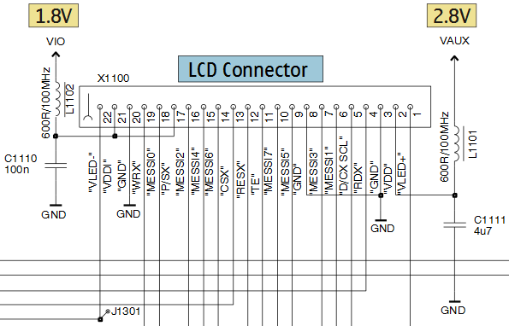 8 D2

9 D4

10 D6

11 Csx

12 Resx

13 Te

14 D7

15 D5

17 D3

18 D1

19 D/Cx_Scl

20 Rdx

22 Vdd

23 Vled+